LIVE OAK
JUNIOR HIGH
STUDENT HANDBOOK
2025 - 2026


LOJH Student Password Tracker
Student Lunch Number:

Login Formats:
Computer + Clever | 1st initial, last name(may have to add a number*) Ex. jdoe2 | First three of the first name, student ID#!  *if the student's ID has less than 6 digits, you will have to use a 0 in front of the number.  Example-John Doe, student ID# 12345  User name - Jdoe2 Password- Joh012345!
Google + Microsoft | computerusername@stu.lpsb.org | Computer password
Powerschool  Student | Click on “Student Sign in” | Sign in with Google Account

Your Login Information:
Computer + Clever
Google + Microsoft
IXL

Contents

Student/Parent Guidelines | 2
Attendance Guidelines | 3
Academic Policies | 4
Make-up Work | 6
Behavior/Discipline | 7
Dress Code | 12
Food/Drink | 14
Guidance/Library | 15
Medication/PE | 16
Student Fees/Technology/Transportation | 17
Social Media Info. | 20
Title I Info. | 21
Daily Schedule/Important Dates | 23
Parent Help Page | Back Cover


LIVE OAK JUNIOR HIGH
35086 Old Highway 16
Denham Springs, LA 70706
TELEPHONE 225.667.4195 / FAX 225.667.4196
www.liveoakjuniorhigheagles.com

Student Name: __________________________________________ Grade:___________

Address: ___________________________________________________________________

Phone Number:______________________ Cell Number: ________________________

Bus Number:____________________ Bus Driver’s Name: ________________________

Breakdown Bus Name / Number: _____________________________________________
As a longtime Watson resident, I know firsthand the pride, tradition, and responsibility that come with being part of the Eagle family. It’s an honor to welcome both new and returning students as we begin another exciting year together.
Alongside our dedicated faculty and staff, my goal is to ensure you have a meaningful and rewarding experience—both in and out of the classroom. This year, we’ll continue to challenge you to strive to achieve our Four Cultural Tenants every day. Whether it’s through academics, extracurriculars, or personal growth, we believe in your potential to soar.
Let’s make this year one of growth, achievement, and school spirit! Good luck and remember: It’s a great day to be an Eagle!
Dr. Eric Fasbender, Principal

Four cultural tenants
1. Trust
Believe in each other. Trust means knowing you’re safe and supported by your classmates, teachers, and school.
2. Respect
Treat others the way you want to be treated. Respect everyone’s feelings, space, school rules and traditions.
3. Effort
Always try your best. Working hard helps you learn, grow, and reach your goals.
4. Advocate
Speak up for yourself and others’ needs and ideas. Help make our school a better place by sharing ideas and supporting each other.

STUDENT GUIDELINES
Live Oak Junior High is committed to the improvement of our school and community through education. We believe that all students are capable of success. All students at LOJH are to follow the school-wide behavioral expectations in order to help maintain order and contribute to the overall learning environment of the school. All students are not only to meet the following expectations as part of this effort but are encouraged to exceed expectations!

PARENT GUIDELINES & ENGAGEMENT POLICY
At Live Oak Junior High, we believe that the partnership between home, community, and school is vital to the success and improvement of our students and their future. We recognize that parents and guardians play an essential role in supporting their children's education and fostering a positive learning environment. To help maintain order and contribute to the overall success of our school, we encourage parents to:

- Reinforce the school-wide behavioral expectations at home, emphasizing the importance of respect, responsibility, and safety.
- Communicate regularly with teachers and school staff to stay informed about their child's progress and any potential concerns.
- Support their child's academic efforts by providing a structured environment for homework and study, and encouraging a love of learning.
- Participate in school events and activities in a safe, responsible manner; demonstrating to their children the value of education and community involvement.
- Collaborate with the school to address any behavioral issues promptly and constructively, ensuring that disruptions are minimized and learning remains the primary focus.

By working together, we can ensure that all students at Live Oak Junior High are capable of not only meeting but exceeding expectations, contributing to a thriving and dynamic school community.


ABSENCES, ATTENDANCE, CHECK IN/OUT, AND EXCUSES
Livingston Parish Public Schools outline mandatory attendance policies for students in junior high. Student attendance is an important factor in determining a student’s success. Students will be marked absent for each class period they miss, and excessive absences will be reported to the proper authority. Students with excessive absences may be reported to FINS for truancy, and parents will be held accountable for student attendance issues. For more information on student attendance, please visit the LPSB website at www.lpsb.org.

- The Livingston Parish School Board lists documented (medical excuse) personal illness, death in the family, and extreme emergencies as legitimate excuses for absences. All documentation for absences MUST be submitted to the front office within 5 days of the student returning to school. Documentation submitted after this time will not be accepted.
- A student should bring an original doctor’s excuse, obituary, or similar documentation to the office upon returning to school from absence/absences. Please note that faxed or emailed excuses cannot be accepted.
- Suspensions are considered unexcused absences.
- By law the school is obligated to report excessive absences to social services (FINS/OCS).
EXCESSIVE ABSENCES
Regular attendance is an important component to student success. Student who have excessive absences may not receive credit for coursework. LPPS policy states a maximum of 10 unexcused absences for the academic year. Students who have exceeded this number of absences will not be allowed to attend dances, participate in athletics/band events, or school sponsored fieldtrips.

CHECK-IN AND CHECKOUT PROCEDURES
All students who arrive at school late must check-in at the office and pick up an admit slip to class, these students will be marked tardy for the hour they are checking into, unless excused.
Students leaving school before dismissal must be signed out in the office. Students will only be allowed to check out with the people listed on his/her check out card. A state issued ID is required to check out a student. Students are not allowed to text/call or otherwise message home from their personal digital devices, and should request a call home from the office staff.
STUDENT BEREAVEMENT LEAVE
LOJH will grant students bereavement leave of up to three days for the death of an immediate family member without the absences being counted as unexcused. Immediate family members are defined for the purpose of this policy as a student’s parent/guardian, a student’s sibling (step or otherwise), the brother or sister of a student’s parents, or the parent of a student’s parent. Verification of the death and relationship to the student is required to be presented to the school in accordance to the school’s absence excuse policy.
TARDY POLICY
- The office will issue all tardy documentation to students who check in after 7:13 a.m.
- Teachers will issue all other tardies through PowerSchool attendance.
- Students are required to be in the classroom and ready to begin class when the tardy bell sounds.
- Excessive tardies will result in progressive discipline through the office.
Academics

At Live Oak Junior High, we believe academic effort and achievement are key to student success.
We promote a culture of hard work, critical thinking, and resilience to prepare students for future challenges. By upholding high academic standards, we help every student reach their full potential and grow into responsible, lifelong learners.

Grading Policy
At Live Oak Junior High, your final grade in each class is based on three types of assignments. Each type is weighted differently to reflect its importance in measuring your academic progress.

1. MMA – Major & Minor Assessments (80%)
These include tests, quizzes, projects, and other teacher-made assignments. They are graded for accuracy and make up the largest part of your grade. Doing well on MMA assignments is key to keeping your average high.

2. PPT – Progression Towards Proficiency (10%)
These are informal checks like classwork or exit tickets that help show how well you're understanding the material. They count for a smaller part of your grade but are still important for showing progress.

3. UNIT TEST – District Assessments (10%)
These tests are created by the district and given during the year to check your mastery of the content. They help make sure all students are learning at the right pace.

- Important: Each category is calculated on its own. If you want to improve your grade, you need to raise your scores in the same category. For example, a low MMA grade can only be improved by doing better on other MMA assignments.

ACADEMIC DISHONESTY
At Live Oak Junior High, it is essential that all students complete their work with honesty and integrity. Assignments must reflect your own individual effort so that teachers can accurately assess your understanding and abilities.

Academic Dishonesty Includes:
- Copying someone else’s work
- Letting someone copy your work
- Plagiarizing (using someone else's words or ideas without credit)
- Submitting any work that is not your own

Consequences:
Participation/Classwork:
If you submit copied or dishonest work, you may be required to complete an alternate assignment to earn your points, with a note in the gradebook marked “Academic Dishonesty.” Disciplinary action may also be taken.

Major Assessments (Tests, Unit Tests, etc.):
If dishonesty is found on a major assessment, you must retake the assignment under supervision, and administration may assign appropriate disciplinary action, according to LPPS policy.

Reminder: Your work is a reflection of your learning. Honesty matters—in school and in life.


MAKE-UP WORK RELATED TO ABSENCES
When you miss school, it is your responsibility to make up any missed assignments as soon as possible. Here’s what you need to know:

Student Responsibilities:
- Communicate with your teachers to find out what work needs to be completed.
- Check Google Classroom or other platforms for missed assignments.
- Notify your teacher once you’ve completed and submitted make-up work, especially if it's turned in digitally.

Grading and Deadlines:
A temporary “0” will be entered in PowerSchool for any missed work until it is submitted and graded.

Per LPPS policy, you get one extra day for each day you were absent to complete your work.

If you don’t submit the work within the extension and haven’t made other arrangements with your teacher, the “0” will become permanent.

Tip: Stay organized and don’t wait—communicate early and make up your work on time to avoid missing credit.

TUTORING
LOJH is committed to helping students both in and out of the classroom. Tutoring will be available before school from 6:50-7:10am every day. Students are to report directly to the teacher’s classroom that they need tutoring.

LATE WORK ASSIGNMENTS (failure to complete/submit)

To help students stay on track and succeed, Live Oak Junior High enforces the following policy for late assignments:

Late Work Penalty:

Assignments not submitted by the due date will receive a 20% deduction from the earned grade when turned in.

Student Expectations:

Keep up with due dates and manage your time responsibly.

Teachers will notify parents periodically of any assignments marked as a “0” in PowerSchool.

Grading Period Deadlines:

No late work will be accepted after a grading period closes.

For example, assignments given before the first interim must be submitted before interim grades are finalized.

Reminder: Staying on schedule helps you succeed—turn in your work on time to earn full credit.

Behavior
A positive, respectful learning environment is key to student success. At Live Oak Junior High, we work closely with families to support behavior that promotes learning and minimizes disruptions.

Our goals are to:
- Create a safe, supportive, and orderly campus for all students.
- Recognize and encourage positive behavior.
- Address and correct behavior that interferes with learning.

By partnering with parents and guardians, we help students stay focused on academic and personal growth, ensuring every student has the opportunity to thrive.

EAGLES EXCEEDING EXPECTATIONS (E3)
The use of positive reinforcement and restorative discipline will be used to affirm students who are striving for excellence. LOJH will be rewarding students with “E³” when extraordinary behavior occurs. Students receiving E³ will be eligible for prizes drawn once per month and a large prize drawn at the end of each semester. There is no limit to the amount of E³ a student can earn!


PERSONAL DIGITAL DEVICE POLICY (CELL PHONE, SMART WATCH, EARBUDS)
To support a focused and distraction-free learning environment, students may not use cell phones, Bluetooth earbuds, or smartwatches during the school day.
Allowed:
- Devices (cell phones, earbuds, smartwatches) may be brought to school.
- Devices must be turned off and kept inside backpacks during the school day.
Not Allowed:
- Using phones, earbuds, or smartwatches during class time, between classes, or at lunch.
- Texting or calling parents directly from personal devices.

Students who need to contact a parent must fill out a Call Home Slip in the office. A staff member will notify the parent.

Violations & Consequences:
1st Offense: Documented warning
Further Offenses: Escalating consequences, including possible suspension (see Discipline Matrix)

A daily reminder will be announced to help students stay in compliance. Failure to follow this policy may result in disciplinary action according to LOJH guidelines.

*****PLEASE NOTE*****
SMART WATCHES OR OTHER WEARABLE DEVICES ARE NOT ALLOWED ON STUDENTS AT ANY TIME DURING REGULAR SCHOOL HOURS OR SCHOOL SPONSORED TRIPS.

AUDIO, STILL IMAGE, AND VIDEO RECORDINGS
Audio, still image and video recordings are not allowed at LOJH due to FERPA and HIPPA regulations, both of which regulate and protect the right to privacy for adults and minors. Any audio or video recordings at LOJH require the prior approval of the principal. Please note that this policy does not apply to general assemblies, award ceremonies, and other school sponsored events at LOJH. Students in violation of this policy will face office discipline beginning with a short-term suspension and progressing onward.

MINOR DISCIPLINE
At Live Oak Junior High, discipline is part of the educational process. Our goal is to help students develop responsibility, respect, and a positive attitude. All students are expected to Exceed Expectations each day by following school rules and being accountable for their actions.
What is a Minor Infraction?
A minor infraction is any behavior that disrupts instruction or breaks campus procedures. Examples include talking out of turn, not following classroom routines, or disregarding instructions.
Progressive Discipline Process:
- Warning & Redirection
  - Students receive a verbal warning and a chance to correct their behavior.
  - Each warning is documented and verified with the student’s signature.
- Parental Contact & Written Remediation
  - If behavior continues, parents will be contacted.
  - Students will complete a Written Remediation Form, which must be signed by a parent/guardian.
  - This form reviews expected behavior and serves as a documented behavior correction.
- Office Referral & Disciplinary Action
  - After repeated infractions (typically after the 4th), the student will be referred to the office.
  - The office will begin progressive disciplinary actions, which may include detention, suspension, or other corrective measures.
  - Parental contact will be made by administration once an office referral is made.
Reminder: Minor infractions are tracked by each teacher through Kickboard and are carried over between classes. Students who habitually violate expectations will move through each phase of the discipline process.
How to Track Behavior:
Students and parents can monitor behavior and infractions using:
Clever → PowerSchool → Kickboard (click arrow at top right corner)

PROGRESSIVE DETENTIONS
Detention is an alternative to a more severe punishment. It is designed to improve behavior, and it affords the student an opportunity to continue at school and not miss any schoolwork. Detentions are held before school. Failure to attend or comply during detention will result in a progression of discipline. A detention will only be rescheduled once per year. Contact Mr. Everett at matthew.everett@lpsb.org for rescheduling. FAILURE TO ATTEND DETENTION MAY RESULT IN SUSPENSION.
MORNING DETENTION-6:30 a.m.-7:05 a.m. Students must be dropped off in front of the school between 6:15 and 6:20. No student will be admitted late, and students are unable to ride the bus and attend morning detention. Parents must provide transportation.
After-School Detention - 2:15 p.m. – 3:45 p.m. one afternoon a week, as needed. Students will be reminded to stay during the school day. Parents must be present for transportation no later than 3:30. Failure to have timely transportation will prevent further detentions from being scheduled for the students.
Saturday Detention - 8:00 a.m. – 11:30 a.m. Students are to be dropped off and picked up promptly in front of the school. Students will be tasked with cleaning the campus and writing for extended times.
All detentions must be served as assigned; questions should be directed to administrators promptly.

SUSPENSIONS / EXPULSIONS
Suspension from school is used in response to major discipline issues on campus. Students may be suspended for progressive discipline or in response to serious violations of classroom/school/bus rules. Suspensions are used as a deterrent of future behaviors. A student will be recommended for expulsion upon receipt of his/her 3rd suspension.

Students who have one suspension in a semester will be unable to attend fieldtrips or after school dance/activity events for that semester. Students with two suspensions regardless of when they occurred will not be allowed to attend any extra-curricular trips or attend dance/activity night events for the remainder of the school year.


LOJH DISCIPLINE GUIDELINE MATRIX
The following serves as a guideline for common discipline issues and typical consequences for each. The teachers and administrative staff of LOJH may issue other consequences as warranted on a case-by-case situation.

OFFENSE | WARNING/  INFRACTION |  | Morning Detention | AFTER SCHOOL DETENTION | SATURDAY  BEHAVIOR CLINIC | SHORT TERM SUSPENSION | LONG TERM SUSPENSION | EXPULSION
Academic dishonesty-Cheating, submitting others work, plagiarism. | X |  | X | X | X | X | X | X
Breaking and entering school property |  |  |  |  |  |  | X | X
Buying/Selling of personal items at school | X |  | X | X | X | X | X | X
Campus/Classroom Disruption | X |  | X | X | X | X | X | X
Cell Phone Violation |  |  | X | X | X | X | X | X
Disrespect for authority | X |  | X | X | X | X | X | X
Distribution/Possession/Use of Controlled Dangerous Substance |  | LAW ENFORCEMENT MUST BE NOTIFIED |  |  |  |  |  | X
Dress violations | 1-4 |  | 5, 6 | 7, 8 | 9 | 10 +
Failure to serve assigned consequences |  |  |  | X | X | X | X | X
False charges against authority |  |  |  |  | X | X | X | X
Fighting |  | LAW ENFORCEMENT WILL BE NOTIFIED |  |  |  | X | X
Fighting (Continuing to fight after school requested to stop) |  |  |  |  |  |  | X | X
Fighting (multiple offenses) |  |  |  |  |  |  | X | X
Forgery of administrator, teacher, or parent’s signature/Lying |  |  | X | X | X | X | X
Gambling |  |  |  |  | X | X | X | X
Gum | X |  | X | X | X | X
Harassing student or school personnel | X |  | X | X | X | X | X | X
Inappropriate physical contact | X |  | X | X | X | X | X | X
Inappropriate non-uniform dress | X |  | X | X | X | X
Indecent Behavior |  |  | X | X | X | X | X | X
Instigating major disturbance/fight |  |  |  |  | X | X | X | X
Leaving/Missing class without permission |  |  |  |  |  | X | X | X
Out of area | X |  | X | X | X | X | X | X
Possession/Use of alcohol/medication |  |  |  |  |  | X | X | X
Profane and or explicit language/imagery or clothing |  |  |  | X | X | X | X | X
Recording unauthorized audio/video |  |  |  |  |  | X | X | X
Smoking, dipping, possession (lighter/matches), vape, or other tobacco product; POLICE WILL BE NOTIFIED. |  |  |  |  |  | X | X | X
Tardy violations | 1-4 |  | 5,6 | 7, 8 | 9 | 10 +
Technology Loaner (resets each semester) | 1-4 |  | 5,6 | 7,8 | 9 | 10+
Theft |  |  |  |  |  | X | X | X
Unacceptable/unauthorized use of computers or school property. |  |  | X | X | X | X | X | X
Use/possession of any object as a firearm or weapon |  | LAW ENFORCEMENT WILL BE NOTIFIED |  |  |  |  |  | X
Use of Smart watch, or Bluetooth devices in violation of the school Personal Digital Device Policy | X  FIRST OFFENSE |  | X | X | X | X | X | X
Vandalism/destruction of school property (reimbursement may be required) |  |  |  |  |  | X | X | X
Willful Disobedience | X |  | X | X | X | X
Other offenses and punishments may be added if necessary. | X |  | X | X | X | X | X | X

DRESS CODE
The following guidelines have been established by LPPS regarding all students’ dress and appearance.
- School uniform tops and bottoms must be worn every day. Uniform tops must be visible.
- Appropriate footwear must be worn to school (no shower shoes, flip-flops, crocs, slippers or sandals).
- The wearing of caps, hats, hoods, or un-prescribed glasses is not permitted. Students who habitually violate this may face office discipline after receiving a warning.
- Patches, decorations, slogans, symbols, tags, marks, or advertisements are prohibited. (Examples: beer, cigarettes, drugs, obscene suggestions, sexual connotations, etc.)
- Designs, emblems, insignias, monograms, and logos are prohibited.
- Piercings, other than ears, are not permitted (studs only). Earrings should be of a size and dimension that is not a safety concern.
- Hair must be neat, clean, and out of the student’s eyes. Hair should be one natural color; no extreme unnatural colors will be permitted. Sculptured hair styles that include pictures, symbols, letters, numbers, or hair curlers, rollers or excessively teased will not be permitted. Principals have discretion if a hairstyle including accessories interferes with learning.
- Neatly groomed facial hair is acceptable.
- Tattoos must be covered.
- Foundation garments must be worn.
- Outerwear that does not comply with the LPPS uniform policy will be confiscated from the student and returned at the end of the day.
- Dress during any period where uniforms are not required, such as special event days or for transferring students, shall be consistent with the intent and spirit of the School Uniform Dress Code.

NON-UNIFORM DRESS DOWN DAYS
On occasion students will be permitted to wear apparel other than the school uniform. It is important that in ALL cases, the dress is school appropriate (length of shorts, coverage, etc.). Students are not to wear hats, caps, hoods, inappropriate images/wording, or clothing that would otherwise violate the students dress guidelines. Students whose clothing is deemed inappropriate will be required to change into a school uniform. Students who are in violation of this policy maybe disciplined and/or lose the opportunity to participate in free dress on future dates.

***PLEASE NOTE: Students who choose to wear leggings MUST wear shorts over the leggings, and students who wear athletic “Nike” style shorts or “Tennis” style skirts MUST wear leggings or tights of some type under their shorts. ALL OTHER SCHOOL UNIFORM RULES APPLY***
Spirit Shirt Fridays: Students who purchase a Spirit Shirt OR earned a LEAP Achievement shirt can wear them each Friday with uniform bottoms.
LPPS STUDENT UNIFORM DRESS CODE
Shirts:
- Solid Color – Navy Blue or White.
- Polo - two, three or four buttons at the top front with collar (short or long sleeve).
- Oxford style dress shirt, short or long sleeves.
- All shirts are required to be tucked in
- Designs, emblems, insignias, monograms and logos are prohibited.
Undershirts:
- Solid White Only, no color trims on undershirts.
Jumpers/Pants/Skirts/Shorts/Skorts:
- Solid color: Khaki.
- No jean, knit, jegging, stretch, cargo, capri, or cropped styles.
- Appropriate fit: not too loose, not too tight; no sagging.
- Pants must have belt loops and mandatory belt.
- Must be worn at the waistline.
- Jumpers and skirts should be to the top of the knee.
- Shorts and skorts should be no more than 4 inches above the knee; cannot be below the knee; shorts may be cuffed or not cuffed.
- All bottoms must be hemmed.
- Length: Top of knee to four (4) inches above knee (length cannot be below the knees) (length can be cuffed or not cuffed).
Belts:
- Belts required with clothing designed with belt loops, any color, no inappropriate logos or slogans.
Belt buckles must be plain, no studs or spikes.
- Belts are to be worn correctly and buckles are not to be excessive size or offensive design.
Socks:
- Socks may not have inappropriate or offensive wording or images.
- Socks above the knee are prohibited.
- Tights or leggings: solid color black, gray, navy blue, or white. Tights or leggings may only be worn under skirts/ dresses / jumpers and be full length reaching the ankle.
Pullovers:
- Solid Navy Blue or White (¾ zip, crew neck, hoodies, sweaters) are allowed. A pullover cannot be worn in place of a shirt nor be so large that it conceals a student’s bottom garment. Designs, emblems, insignias, monograms and logos are prohibited.
- Any SPIRIT pullover purchased from the school or a vendor with the school's name or logo is acceptable.

Shoes:
- Closed-toe and closed-heel shoe mandatory (tennis shoes, dress shoes, casual shoes, slip-on shoes, or boots).
- Footwear shall not extend above the knee.
- Shoes shall be properly tied or strapped, if applicable.
- NO Crocs and Slipper-style UGG shoes
Coats:
- Coat/Jacket/Sweater may be worn as long as the uniform shirt collar is revealed under coat/jacket/sweater.
- No trench coats allowed.
- Vest/Jackets/Sweaters/Coats that zip/button/snap from top to bottom may be any color and with a hood.

FOOD/DRINK
To protect technology, maintain cleanliness, and promote safety, no food or drinks are allowed in classrooms.
Allowed Items:
- Water only in a clear, plastic, refillable bottle with a secure, spill-resistant lid.
- Opaque containers (Yeti, Stanley, Hydro Flask, etc.) are not permitted.
- Energy drinks, coffee, and supplements are not allowed unless medically approved and handled through the school nurse.
Lunch Guidelines:
- All food must be in non-branded packaging, per LPPS policy.
- Items dropped off for students will not be delivered until the end of the school day.
- NO outside beverages (i.e. juice, soft drinks, energy drinks, etc). WATER ONLY
Consequences:
- Violations result in a dress code infraction.
- Prohibited items will be held in the office until dismissal.
Gum:
- Gum chewing is not allowed and will result in a dress code referral.


GUIDANCE
The purpose of the guidance program is to help each student achieve his/her maximum growth mentally, emotionally, and socially. We try to do this in several ways:
- Individual conferences whenever a student, a teacher, a parent, or the counselor deems it necessary.
- A testing program designed to help a student learn as much as possible about his/her capabilities.
- Support groups designed to help the student deal with issues such as relationships, self-esteem, drugs, loneliness, etc.
- A student may obtain appointment forms to see the Guidance Counselor from his/her teachers or the Guidance office.
- Parents are to call the Counselor to set up all teacher conferences.

*** Students can request a Guidance appointment through the LOJH Student Google Classroom page.***

STUDENT SEXUAL HARASSMENT POLICY
The Livingston Parish School Board disapproves of and does not tolerate sexual harassment by employees to students, by students to employees or by one student to another student. No employee or student, either male or female, should be subject to unsolicited and un-welcomed sexual overtures or conduct, either verbal or physical. Sexual harassment does not refer to occasional compliments of socially acceptable nature. It refers to behavior that is not welcomed, that is personally offensive, and therefore interferes with the purposes of the employee and/or student in the academic, extracurricular, and co-curricular atmosphere. Students could be recommended for suspension or expulsion. Examples of sexual conduct are: • Sexual advances • Touching of a sexual nature • Graffiti of a sexual nature • Displaying or distributing of sexually explicit drawings, pictures and written materials. • Sexual gestures • Sexual or “dirty jokes” • Pressure for sexual favors • Touching oneself sexually or talking about one’s sexual activity in front of others. • Spreading rumors about or rating other students as to sexual activity or performance. This policy applies to all.
LIBRARY
- Students will go to the library with their ELA class.
- Students will be charged $.05 per day for overdue library books.
- Students must pay for lost or damaged books.
- Students are limited to checking out two books at a time for a period of two weeks.
- Reference materials, magazines and newspapers must be used in the library.

MEDICATION FOR STUDENTS
The school is NOT allowed to administer nonprescription medication (Tylenol, Ibuprofen, cough syrup, Advil, etc.), nor is a student allowed to bring/possess such medication on campus, or other non-prescription supplements. Parents may come to the school and administer these medications to their child. If a student needs to take a prescription drug during school, the following must be followed before medication can be administered:
- The Parental Permission Form and the Doctor’s Order Form (available upon request from the Office) must be completed, signed and returned to the school.
- The medication must be in the original prescription bottle with the correct and current information on the bottle. DO NOT WRITE ON THE BOTTLE; IT INVALIDATES THE PRESCRIPTION. Only adults can bring medication to school.
- The office should be notified IN WRITING regarding allergic reactions/procedures for individual students. This information should be provided at the earliest possible convenience.

POWERSCHOOL PARENT PORTAL
PowerSchool Parent Portal gives parents and students access to real-time information including attendance, grades and detailed assignment descriptions. Everyone stays connected: Students stay on top of assignments, parents are able to participate more fully in their student's progress, and teachers can use their grade book to make decisions on what information they want to share with parents and students. The web address for the Parent Portal is as follows: http://powerschool.lpsb.org/public. Parents are cautioned to keep their passwords private.

PHYSICAL EDUCATION
- All students not medically excused will participate in Physical Education.
- There will be penalties for habitual failure to dress out for class.
- Each child must have a gym uniform. Gym uniforms may be purchased from the school for $25.00.
- Athletic style shoes and socks are required; shoes must have non-marking soles and must tie or fasten.
- Each child should have his/her name clearly printed on the gym uniform. Students may not borrow or loan gym uniforms.
- In order to participate in P.E., if a student’s uniform is lost, stolen or damaged, a new uniform must be purchased.
- A student’s grade in P.E. will be based on dressing out, participating in skills, and written tests.
- Students are required to participate in regimented physical exercise as part of their grade. Students who refuse will face discipline for willful disobedience.

STUDENT FEES
- Students are assessed a $75.00 school fee for our current school year. Students MUST have their student fee paid in order to participate in $5 academic dress down weeks, attend dances, or field trips.
- P.E. uniforms are $25.00.
- Band fees are $60.00 for band students only
- Personal Computer Insurance is available for $25.00 for each device, covering up to Two (2) insurance claimed repairs per academic year.
- Students must pay for lost or damaged textbooks, computers, chargers, and library books.
- There may be additional class/club fees assessed; they must be paid to individual teachers/departments.
- Unpaid debts and/or fees could result in student not participating in field trips or extra-curricular activities

TECHNOLOGY
Each student at LOJH will be issued a school use laptop. Students are responsible for the well-being, up-keep, and damage repairs of these devices. Each student must return a parental acknowledgement of liability form before the devices can go home. Insurance is available through the school at a cost of $25.

***Each student and parent will be required to sign a user agreement before a laptop is issued.***

Students who forget to bring their laptops to school will be allowed Four (4) checkouts from the library each semester before disciplinary action takes place. Discipline will follow the Tardy/Dresscode progression (see Discipline Matrix)

TRANSPORTATION
BUS RULES
- Students are expected to be at their assigned bus stop each morning.
**Bus drivers are not required to blow horns or wait on students who are not at the bus stop.**
- Students must always remain seated when the bus is in motion.
- Students should adhere to all guidelines concerning bus safety.
- Camera equipment may monitor students’ behavior on school buses.
- Additional bus rules will be provided/required by individual bus drivers; please try working with them as a first step in solving individual problems.
- The same discipline applies to the bus as it would in the classroom.

CARPOOL DROP-OFF AND PICKUP PROCEDURES
In order to maintain the safety and efficiency of the carpool line at LOJH, please ensure the general guidelines are followed, and the directives of the on dutyteachers are followed. Students may be dropped off and picked up by parents before or after school, but please follow the indicated blue pathway in the parking lot. Cars may only enter the school parking lot via Calmes Drive. Vehicles turning off of 1019 or Eagle Drive will not be permitted to enter the carpool line. NO student is to be dropped off before a duty teacher is present at 6:50am, and students should be picked up no later than 2:25pm.

Carpool students may be marked tardy if they arrive to campus late, and are unable to be in class by 7:13am. LOJH is not responsible for students who are late due to traffic congestion, weather, or other unforeseen instances. Students arriving to campus after 7:10am will be directed to the front of the school to check-in through the office, and will be marked tardy.

Please review the carpool map below and view our instructional video by scanning the QR code next to the map.

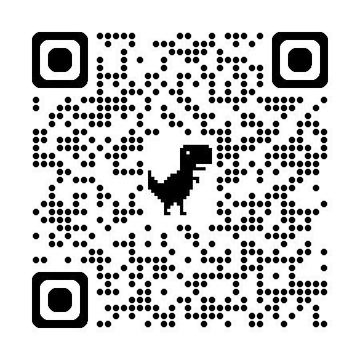
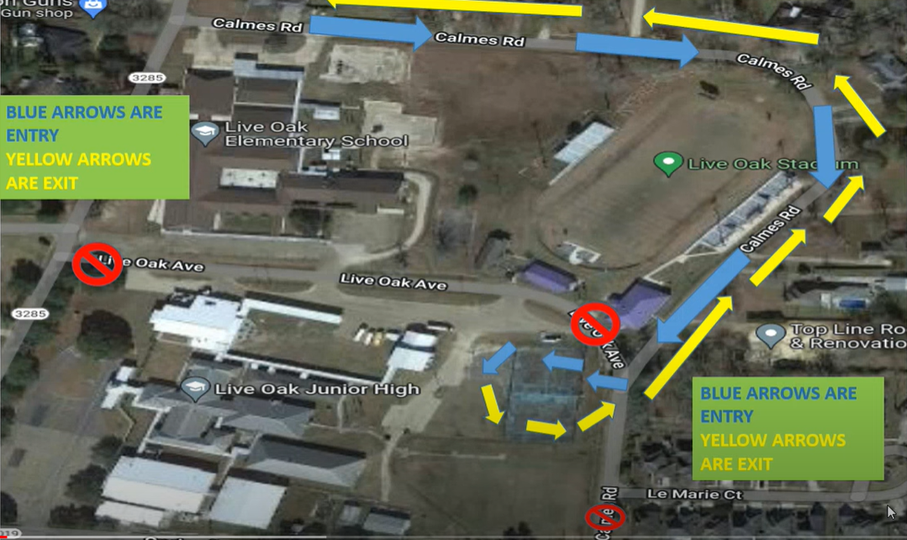
*Carpool hints:
- Student should be ready to exit the vehicle from the passenger side if possible.
- Students should gather bags, instruments, and other items before exiting the vehicle.
- Students should exit the traffic area quickly and report to their designated areas.

Failure to follow the carpool guidelines may result in the loss of a student’s ability to use this form of transportation.

- Students who provide their own transportation to school MAY NOT BE DROPPED OFF BEFORE 6:50 A.M.
- Any changes in a student’s method of transportation in leaving campus will require written permission from a parent or guardian and must be approved by the principal or assistant principal before school begins. DUE TO OVERCROWDED CONDITIONS ON BUSES, STUDENTS WILL NOT BE ALLOWED TO RIDE A DIFFERENT BUS UNLESS APPROVED BY THE OFFICE.
- Extra-Curricular events: Students who are unable to have timely rides after events will not be able to attend further events.

LPPS ACCEPTABLE USE SUMMARY
In our continued efforts to comply with the Children's Internet Protection Act, Livingston Parish Public Schools has adopted and will enforce policies and procedures to protect our students. The policies: IFBGA Computer Access and Use and JCDAF - Bullying, Cyber Bullying, Intimidation along with other district policies are available to the public at the school or district administrative office.
Acceptable use of the internet and other network resources include but are not limited to:
- No access by minors of inappropriate matter
- No access of social networking or gaming sites
- No use of outside electronic mail, chat rooms, and any other forms of direct communication by students
- No inappropriate network behavior including cyber-bullying
- Any knowledge of prohibited behavior or access of prohibited sites must be reported immediately
- Students are not allowed to install any software on LPPS computers or networks
- No revealing personal information
- No illegal activities such as:
- Hacking, Vandalism and unauthorized access.
- Password abuse
- Inappropriate language
- Trespassing in others’ folders
- Damaging computers or networks
- Disabling or modifying LPPS security settings in order to bypass filtering/monitoring to gain unauthorized access to sites or files
- Violating Copyright laws
- Spreading viruses or using the network for commercial, illegal or violent purposes
Penalties:
- Any user violating these provisions, applicable state and federal laws, and district rules shall be subject to loss of network privileges and any other system disciplinary options, including criminal prosecution.

- Procedures that have been adopted to enforce the policies include:
- Principals will discuss CIPA and Acceptable Use with the staff to explain their responsibilities. Teachers sign a form with the items discussed and their responsibilities listed.
- Teachers will disseminate the information to students. As documentation of discussion, students in grades 3 and above must sign a statement that they have been informed of and understand their responsibilities as network users. This form also contains a list of items discussed.
- LPPS also maintains a robust software platform that filters inappropriate material and blocks its access for all users. This software scans emails and internet sites for key words and identifiers. The district reviews filtering reports and internet use regularly to insure protection for students and appropriate use by staff.
- All photos of students on school websites will be unidentified unless a permission form has been completed.
- It is the responsibility of the parent to go to the school in person and sign a form if you want to:
- Deny your student access to the internet.
- Deny permission for your student’s work to be published on classroom web sites.
- Deny permission for your student’s unidentified photos to be published on classroom web sites.

OFFICIAL LOJH PLATFORMS
To keep parents and guardians informed, Live Oak Junior High offers several digital platforms:
- LOJH App – Download for free by searching "Live Oak Junior High" in the App Store or scanning the QR code on the inside back cover.
- Facebook – Follow the Live Oak Junior High page for updates and announcements.
- Website – Visit www.liveoakjuniorhigheagles.com for official information.
- KiNvo – Stay connected through this PowerSchool-supported texting service used by our faculty and administration.
***The student handbook is posted on the Live Oak Junior High website and is available on the LOJH App. Changes to the handbook may be made at any point during the school year. Notification will be sent if/when any changes are made.***

CHILD FIND
In accordance with the State of Louisiana Child Search Program, annual and ongoing activities are conducted to identify and locate children (ages 3 through 21) suspected of being exceptional and in need of special education and/or related services. If you have a child or know of a child between the ages of 3 and 5 years old who seems to have difficulty learning, help is available. Contact the Livingston Parish Public Schools Child Search Coordinator at (225) 686-7600. If your child is school-aged, contact your home-based school district regarding these concerns.

LOJH COMMITMENT TO THE COMMUNITY

THE ADMINSTRATION, FACULTY, AND STAFF ARE COMMITTED TO THE BETTERMENT OF OUR COMMUNITY THROUGH EDUCATION. WE ARE HERE FOR YOU! WE BELIEVE THAT THE ROLE OF THE SCHOOL IS TO UNLOCK THE POTENTIAL OF OUR STUDENTS. EACH STUDENT HAS EQUAL OPPORTUNITY FOR SUCCESS IN OUR SYSTEM. THE SCHOOL IS A HUB OF CONNECTIVITY, COMMUNITY, AND COMPASSION.

WE PLEDGE TO GIVE OUR ALL SO THAT OUR STUDENTS CAN BE THEIR ALL.

TITLE I Family Engagement Policy
LPPS 2025 -26

A Districtwide Family Advisory Council has been established in order to revise the current Livingston Parish Title I Parent and Family Engagement policy and expand the plan in accordance with Every Student Succeeds Act (ESSA) of 2015, section 1112 of the Elementary and Secondary Act (ESEA). This council will meet regularly in order to coordinate and integrate family involvement, and evaluate the effectiveness of the policy. This policy will be made available to the local community and updated periodically to meet the changing needs of the families and the school. The ultimate goal is to ensure that all families within the district are provided the same opportunities for involvement in their child’s education. The advisory council will also be informed of the process of the 1% of Title I, Part A funds reserved for family engagement. The Local Education Agency (LEA) will incorporate these ideas into the district-wide policy. If there are any unsatisfactory comments on the plan, these will be forwarded to the State Education Agency (SEA).

Under the direction and technical assistance of the Local Education Agency (LEA), each Title I school will have family members serve on the Schoolwide Committee, which will function to review the schoolwide plan and family activities for that school. This plan will be specific to the Title I school and will provide a means for families to become more involved in their child’s education.

Consistent with section 1118 of the ESEA, an annual meeting will be held in each school in which family members will be given information about their school participation in the Title I program and related services, an explanation of the requirements of this participation and a school/family compact as required by section 1118(d) of the ESEA.. Family members will also be informed of their right to parent-teacher conferences, regular reports on their children’s progress, reasonable access to staff, opportunities to volunteer on campus, and to request information regarding the professional certifications of their student’s classroom teachers. To the extent, which is practical, meetings will provide full opportunities for the participation of family members with limited English, members with disabilities and migrant parents following section 1111 of the ESEA. Information will be understandable and uniform.

One goal of this plan will be to improve communication between home and school through family/school compacts, newsletters, family-teacher conferences, handbooks, agendas, surveys, School Messenger recordings, electronic communications, such as: telephone calls, texts and emails, and school social media types of sharing information. It is important that family members respond to communications from the school in a timely manner and talk with their children about their classroom activities and behavior.
Another goal will be to provide information concerning Every Student Succeeds Act (ESSA) of 2015, the State of Louisiana Accountability Law, the curriculum used at the school, the forms of academic assessment used to measure student progress, and the proficiency levels students are expected to meet.

Title I schools will assist families with parenting skills, technology skills, and give assistance in helping with homework, projects, and other at-home activities. Families will be encouraged to take advantage of teacher conferences as a way of monitoring the progress of students. Schools will also provide opportunities for the local community to become more involved with families and with the school.

Family participation is essential to the success of the students. By monitoring the child’s progress and working with educators to improve students’ achievement, families provide a vital link between the school and the student. Students should know that their family values education and achievement and are available to help them to achieve their goals. Annually, each school will disseminate and collect family surveys to improve engagement. Results from the survey, if needed, will be used to revise family engagement policies at the school level.

It is Livingston Parish Public School System’s goal to reach out to, communicate with and work with families as equal partners in our schools.

DAILY SCHEDULE/IMPORTANT DATES

STUDENT DROP OFF |  |  | 6:50-7:10
1ST HOUR |  |  | 7:13-8:11
2ND HOUR |  |  | 8:14-9:07
3RD HOUR |  |  | 9:10-10:03
4TH HOUR |  |  | 10:06-10:59
5TH HOUR  (LUNCH) | A |  |  | LUNCH-10:59-11:21
5TH HOUR  (LUNCH) |  |  |  | CLASS- 11:24-12:17
5TH HOUR  (LUNCH) | B |  |  | LUNCH-11:27-11:48
5TH HOUR  (LUNCH) |  |  |  | CLASS-11:02-11:27/11:50-12:17
5TH HOUR  (LUNCH) | C |  |  | LUNCH-11:55-12:16
5TH HOUR  (LUNCH) |  |  |  | CLASS- 11:02-11:55
6TH HOUR |  |  | 12:20-1:13
7TH HOUR |  |  | 1:16-2:13
SCHOOL HOLIDAYS
LABOR DAY |  | MONDAY 9/1/2025
LIVINGSTON PARISH FAIR |  | THURSDAY – FRIDAY  10/9 & 10/10/2025
THANKSGIVING |  | MONDAY-FRIDAY  11/24-28/2025
CHRISTMAS/ NEW YEAR’S |  | FRIDAY 12/20/25 –  TUESDAY 1/6/26
MARTIN LUTHER KING DAY |  | MONDAY 1/19/26
MARDI GRAS |  | MONDAY-WEDNESDAY  2/16/26-2/18/26
GOOD FRIDAY/EASTER |  | MONDAY-FRIDAY  3/30/26-4/3/26

“IT’S A GREAT DAY TO BE AN EAGLE!!”

    GOOGLE CLASSROOM HELP |   POWERSCHOOL
Most assignments are posted in “GOOGLE CLASSROOM”. This online service features real-time updates for work, and connects directly to Google Drive. This means assignments cannot be lost. Visit the link below for some helpful info on making the most of your efforts in Google Classroom!  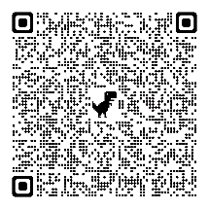  Google Guardians: An online training on how it works! | POWERSCHOOL is an online gradebook for all students. Teachers are able to add comments, mark assignments late, incomplete, or missing. POWERSCHOOL keeps track of student absences and tardies as well. LOJH strongly encourages parents/guardians AND students to regularly check POWERSHOOL for updates on grades!  POWERSCHOOL is the most effective means of seeing a student’s progress in class...    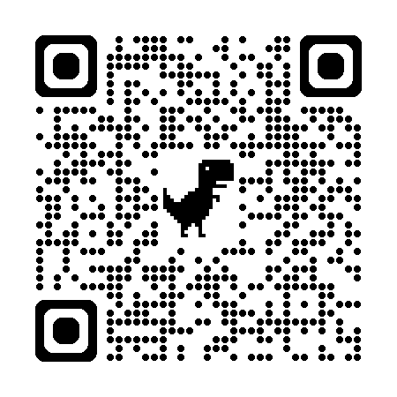  Watch an overview video  Download the POWERSCHOOL Mobile APP through the Google or Apple Play store. Use district code below to get started:  NQPT
LOJH Platform QR Codes | Who to Contact?
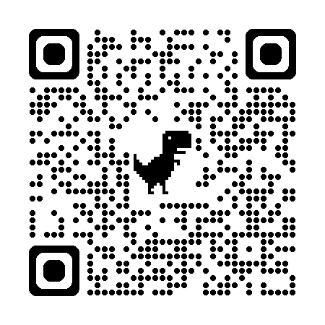LOJH APP  LOJH Website:  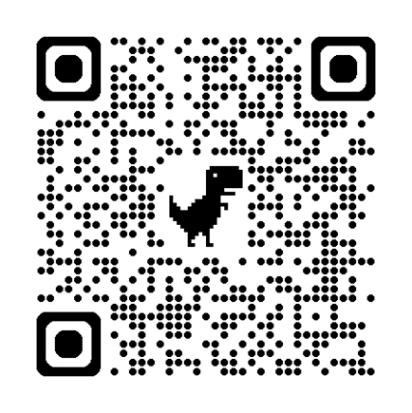 | LOJH is a dedicated school community working together to support student success. To help you get answers quickly, please review the guide below.  Classroom Questions:  Email teachers directly using firstname.lastname@lpsb.org  i.e. john.smith@lpsb.org  Office/Secretarial Questions:  Mrs. Sharon or Mrs. Lindsey, Secretaries  sharon.mccon@lpsb.org or lindsey.tadlock@lpsb.org  Bus/SPED:  Mrs. Wilson, Asst. Principal melissa.wilson@lpsb.org  Discipline:  Mr. Everett, Admin. Asst. matthew.everett@lpsb.org  Academics:  Mrs. Lavergne, Instructional Coach nikki.lavergne@lpsb.org  Schoolwide concerns:  Dr. Fasbender, Principal eric.fasbender@lpsb.org  Counseling/Scheduling Conferences:  Ms. Kistrup, Counselor keri.kistrup@lpsb.org

